Using the Air Sports Live Tracking results service

The results service is a mostly standalone tool designed to record results for air sports competitions. It allows for easy creation of tasks and tests, and entering scores for individual contestants inside a test. It is integrated with the live tracking such that for a navigation task (precision, ANR, air sports, poker run) a task and test is automatically created in the results service, and I’ve scoring results are immediately updated in the results table.

# It is alive

The contest results table is fully synchronised. This means that if you open the table in a web browser somewhere it will immediately reflect any changes that are made anywhere else. This makes it well-suited for a display screen in public areas, immediately showing any scoring changes done in the back room.

# Teams

Teams are added to the contest results on the contest management page you reach from <https://airsports.no/contests/>. After creating or finding your contest, from the contest details page you enter the team list by clicking the corresponding link at the top:



This gives you an overview all the teams registered for the contest. Contestants can register themselves using the Air Sports app, or you can add teams by clicking the “Add team” button at the bottom.

From the contest details page you also find a direct link to the contest results table.

# Contest configuration

From the contest details page you can update the contest configuration via the “management” button. In this form (same as when creating the contest initially) the “Results service” section controls the behaviour of the overall contest score in the results table. The summary score sorting direction is used to indicate whether the lowest (ascending) or highest (ascending) score is the best, i.e. should be at the top of the table.

The checkbox “Autosum scores” controls whether the overall contest score should be entered manually by the organizer (unchecked) or calculated automatically (checked). During automatic calculation (the default), the overall contest score is continuously updated whenever a task score is updated, according to the weight of the task scores.

# Tasks and tests

The results service is built around tasks and tests. A contest consists of one or more tasks, and each task consists of one or more tests. The task score is the weighted sum of all tests, and the overall contest score is the weighted sum of all tasks.

## Creating a task

You create a new task by clicking the “New task” button in the top right corner above the results table.

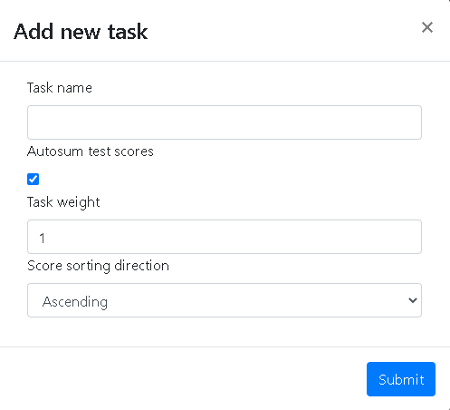

In the form that pops up, provide a task name and check “Autosum test scores” if you want the task score to be the weighted sum of all the test scores. If this is not checked, you must provide the total score for the task yourself.

Task weight represents the fraction of the total score for this task that should make up the total score for the contest. The default value of 1 means that the full value of the task score is added. Inputting for instance 0.5 will only include half the value. Finally, score sorting direction controls whether the smallest value is the best (ascending) or the highest value is best (descending).

## Creating a test

Tests are created within a task. To enter the task level, click the magnifying glass next to the task name in the table header . The first column in this view is the total contest score. The next few columns are the various tests for the task, and the final column is the task itself. Return to the contest you by clicking the magnifying glass containing the “-“ symbol next to the task name in the table header.

To create a new test, click the “New test” button at the top of the page.

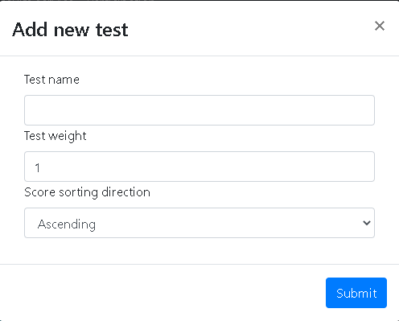

In the pop-up box, fill in the test name, the test weight (the fraction of the score of this test that is included in the task score), and the score sorting direction.

# Making changes

Tasks and tests can be modified by clicking the pencil icon next to the corresponding names. It is possible to reorder the task and test columns by clicking the appropriate arrows.

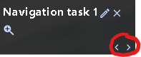

# Entering data

Data can be entered directly in the table in every field that contains a blue “-“. The colour may be difficult to distinguish, so the “-“ is underlined when hovering the mouse to indicate that it can be clicked. By clicking in the field you open up a text input field where you can enter the score for the test and contestant. If you have selected to auto summarise task scores you will not be allowed to directly input a score for the task itself, only for the underlying tests. You will notice in that case that the task score is updated immediately when a test score is entered.

# Live tracking integration

The creation of a live tracking navigation task triggers the creation of a corresponding task in the contest results. Inside the task the test “Navigation” is created and linked to the live tracking task. Any scoring changes during live tracking will be immediately reflected on this test. Since the test and task is linked to a live tracking navigation task they cannot be deleted as long as the live tracking navigation task exists. Deleting the live tracking navigation task will remove the connected test, and also the task if there are no remaining tests.

# Suggested workflow

The suggested way of working with the contours results table is as follows. This assumes a typical contest with multiple navigation tasks and some landing tasks. When we discussed score entry below this will make the data available publicly immediately. For the sake of saving the excitement to the end, maybe not all scores should be entered immediately.

## Initial setup

1. Create the live tracking navigation tasks. This will trigger the creation of the corresponding results table tasks and tests. The tasks will have the same names as the live tracking navigation tasks.
2. Inside each created task, create the necessary tests in addition to the navigation test, for instance observation and planning.
3. Create any additional tasks such as landing, and create one test for each landing type (e.g. with engine, idle, above obstacle, et cetera)
4. Sort the columns using the left and right icons in the table header to make the order represent the order of the tasks. Similarly for the tests within each task.
5. Register the teams and set up all the contestants in the live tracking navigation tasks, and we are ready for the competition day.

## During the competition

1. As the contest progresses, enter scores as they are available for the contestants in the different tests. For instance, once a team has finished its planning task and the score is ready, enter the score for the corresponding test in the table. Similarly for each landing type, and to the score immediately once it is available.
2. The scores from the live tracking tasks will be automatically updated in real time.